Net of cylinder:

1.3 cm
9 cm

8 cm

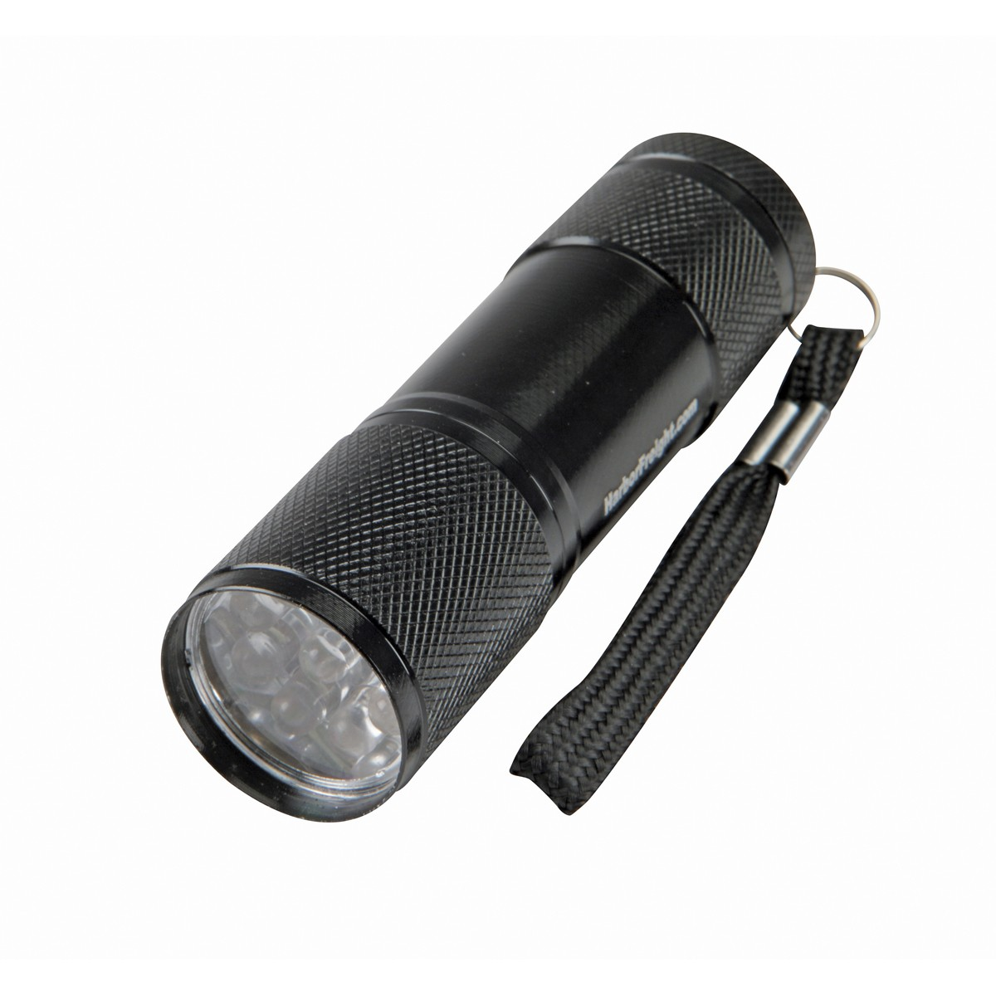
This shape is a cylinder:

1.3 cm=radius
9 cm=height

Area: $A=2⋅π⋅1.3⋅9+2⋅π⋅1.3⋅2 ≈ 84.13$

Volume: $V=π⋅{1.3}^{2}⋅9 ≈ 47.78$

Circumference: $C=1.3⋅2π ≈8$

